McDonald's Menu Nutritional Analysis – Project REPORT

By Gopika Lakshmy K M

gopikalakshmykm@gmail.com

**McDonald's Menu Nutritional Analysis – Project Report**

**Instruction**

McDonald's is a global fast-food chain known for its diverse menu offerings. As a data analyst, your task is to analyze the nutritional content of the menu items available at McDonald's outlets. This analysis will provide valuable insights into the calorie count and nutrition facts of various menu items.

**Objectives:**

1. Extract meaningful information from the McDonald's menu nutritional dataset.
2. Perform exploratory data analysis to understand the nutritional distribution and trends.
3. Create visualizations to present the calorie count and nutrition facts of different menu items.
4. Identify healthy and less healthy menu options based on nutritional content.

**Timeline:**

The project is expected to be completed within two weeks.

**Deliverables:**

A report (PDF) containing:

* Description of data analysis approach and methodology.
* Exploratory data analysis findings and insights.
* Visualizations depicting nutritional information.
* Source code used for data preprocessing, analysis, and visualization.

**Tasks/Activities List:**

1. Data Collection: Download the McDonald's menu nutritional dataset from [this link.](https://kh3-ls-storage.s3.us-east-1.amazonaws.com/Data%20Analyst%20Project/Nutrical%20Dataset.csv)
2. Data Preprocessing:
   * Load and inspect the dataset.
   * Handle missing values and data cleaning if necessary.
3. Exploratory Data Analysis (EDA):
   * Analyze the distribution of calorie counts across menu items.
   * Explore the nutritional content (e.g., fat, protein, carbohydrates) of different items.
   * Identify trends and patterns in the dataset.
4. Data Visualization:
   * Create bar charts, histograms, and box plots to visualize calorie distribution and nutritional content.
   * Compare nutritional characteristics of different food categories (e.g., burgers, salads, desserts).
5. Nutrition-Based Insights:
   * Identify menu items with the highest and lowest calorie counts.
   * Determine the average nutritional content of popular menu categories.
6. Documentation and Reporting:
   * Summarize the findings and insights from the analysis.
   * Explain how the nutritional analysis could benefit McDonald's customers and the organization.

**Success Metrics:**

* The project should provide a comprehensive overview of the nutritional content of McDonald's menu items.
* Visualizations should effectively convey calorie counts and nutritional information.
* Insights should highlight healthy and less healthy food options.

**Bonus Points:**

* Create a Jupyter Notebook or Python script detailing each step of the analysis.
* Package your code and findings in a GitHub repository with a clear README.
* Provide recommendations on how McDonald's could improve the nutritional profile of their menu.
* **Data Cleaning Report**

The dataset was obtained from the given link and analyzed using Python.

Data Cleaning Steps

**Step 1: Column Name Standardization**

* The dataset was reviewed and column names were standardized to ensure clarity and consistency.

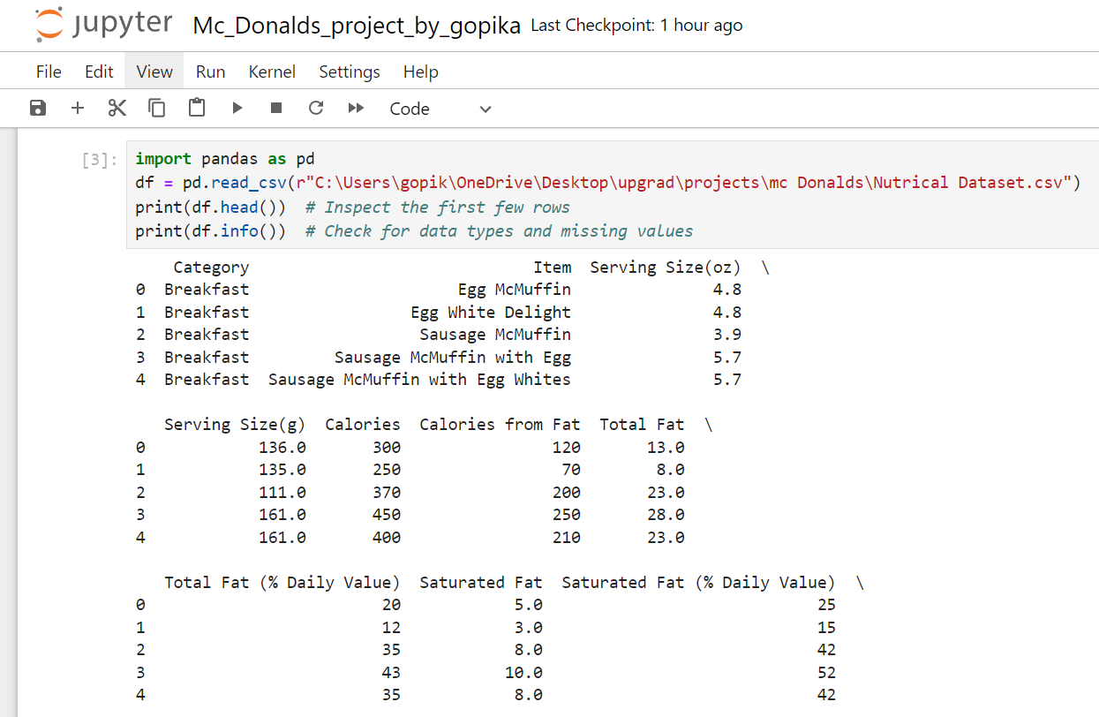

**Step 2: Missing Value Identification and Handling**

* print(df.isnull().sum()) option was utilized to identify blanks or empty cells.
* The missing values were filled by appropriate values for numerical columns.

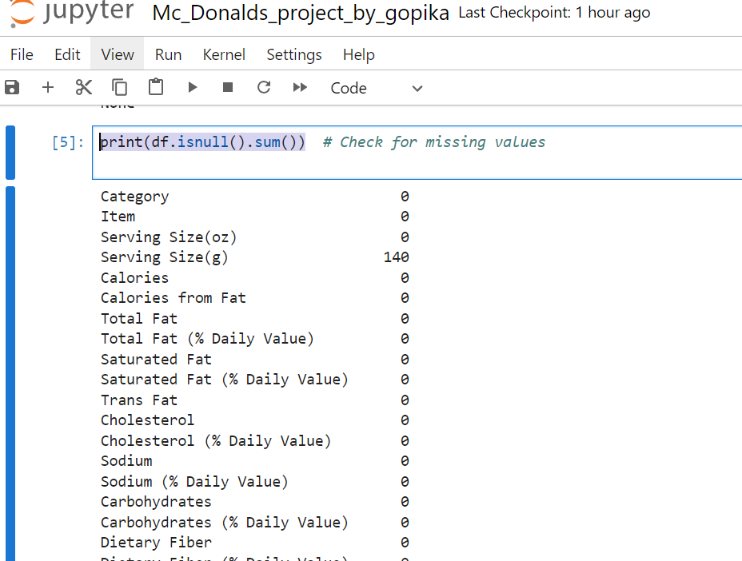

**Step 3: Duplicate Row Removal**

To eliminate redundant data:



**Step 4: Data Format Verification**

To ensure accurate calculations:

* Numerical columns (Calories, Protein, Fat, etc.) were verified to be in the correct format.



The data cleaning exercise has ensured the accuracy and reliability of the McDonald's menu nutritional dataset. The dataset is now ready for analysis and visualization.

* **Exploratory Data Analysis (EDA):**

1. **Distribution Analysis of Calorie Counts Across Menu Items**

To examine the distribution of calorie counts across menu items, a horizontal bar chart was utilized. Due to the large number of items, the analysis focused on the top 10 highest-calorie items.

**Key Findings:**

The analysis revealed that:

1. Chicken Nuggets (40 pieces, 1 serving) contained the maximum calories.
2. Hotcakes (Large and Regular) ranked second and third.
3. Hotcakes and Egg Whites (Large and Regular) followed closely.
4. McFlurry with M&M's Candies was sixth.
5. Chocolate Shake, Strawberry Shake, and Shamrock Shake rounded out the top 10.

**Insights:**

This analysis highlights the calorie-dense nature of these popular menu items, particularly Chicken Nuggets and Hotcakes. These findings can inform nutritional recommendations and menu engineering strategies.

**Recommendations:**

1. Consider offering healthier alternatives or smaller portion sizes.
2. Provide clear nutritional information for customers.
3. Explore reformulation options to reduce calorie content.

**Appendix:**

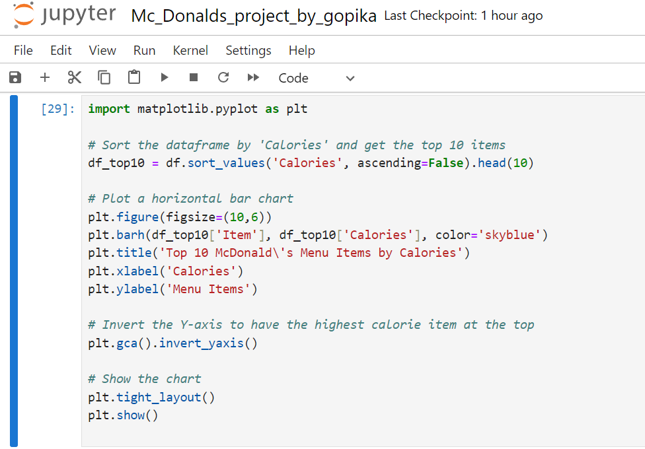

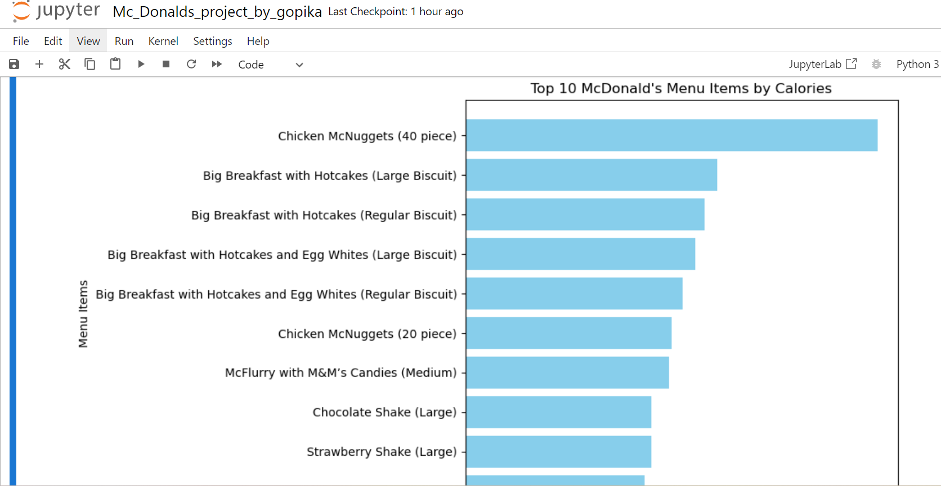

1. **Exploratory Data Analysis (EDA) of Nutritional Content**

**Introduction**

To better understand the nutritional content of various menu items, an exploratory data analysis (EDA) was conducted. This analysis aimed to visualize the variation of essential nutrients across different items.

**Summary Statistics**

Using Python, summary statistics were generated for the nutritional content of the menu items. The results are presented below:

**Mean Nutrient Values**

| **Nutrient** | **Mean Value** |
| --- | --- |
| Total Fat | 14.17g |
| Saturated Fat | 6.01g |
| Trans Fat | 0.20g |
| Cholesterol | 54.94mg |
| Sodium | 495.75mg |
| Carbohydrates | 47.35g |
| Dietary Fiber | 1.63g |
| Sugars | 29.42g |
| Protein | 13.34g |

**Maximum Nutrient Values**

| **Nutrient** | **Maximum Value** |
| --- | --- |
| Total Fat | 118.00g |
| Saturated Fat | 20.00g |
| Trans Fat | 2.50g |
| Cholesterol | 575.00mg |
| Sodium | 3600.00mg |
| Carbohydrates | 141.00g |
| Dietary Fiber | 7.00g |
| Sugars | 128.00g |
| Protein | 87.00g |

**Insights**

The analysis reveals significant variability in nutritional content across menu items. The maximum values for sodium and sugars are particularly notable, highlighting potential areas for nutritional improvement.

**Recommendations**

1. Consider reformulating menu items to reduce excessive nutrient levels.
2. Provide clear nutritional information for customers.
3. Offer healthier alternatives or smaller portion sizes.

**Appendix**

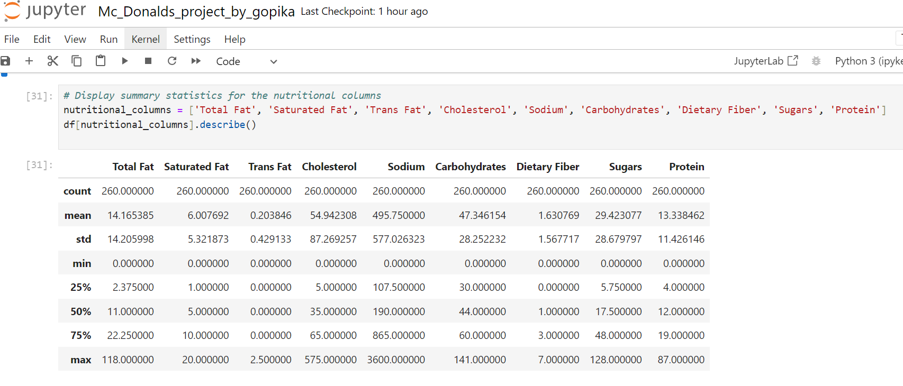

1. **Pairwise Comparison - Boxplots**

To compare the distribution of essential nutrients across all menu items, boxplots were utilized for pairwise comparison.

**Key Insights:**

1. High-Fat and Sodium Content:
   * The box plots for Total Fat and Sodium show high median values with several extreme outliers, indicating that many items on McDonald's menu may be high in fat and sodium content, which can pose health risks if consumed in large quantities.
2. Moderate Protein and Carbohydrates:
   * Menu items offer moderate Protein and Carbohydrates levels, making them a potentially balanced meal option depending on individual dietary needs.
3. Outliers in Sugar Content:
   * The Sugars distribution shows several high-value outliers, highlighting that desserts and sugary beverages can contribute significantly to daily sugar intake.
4. Cholesterol Concerns:
   * Some items have cholesterol levels exceeding 200 mg, which may be concerning for customers with cardiovascular concerns.
5. Low Dietary Fiber:
   * Dietary Fiber levels are generally low across most menu items, indicating that McDonald's menu may lack sufficient fiber content, which is crucial for digestion and overall health.

**Appendix**

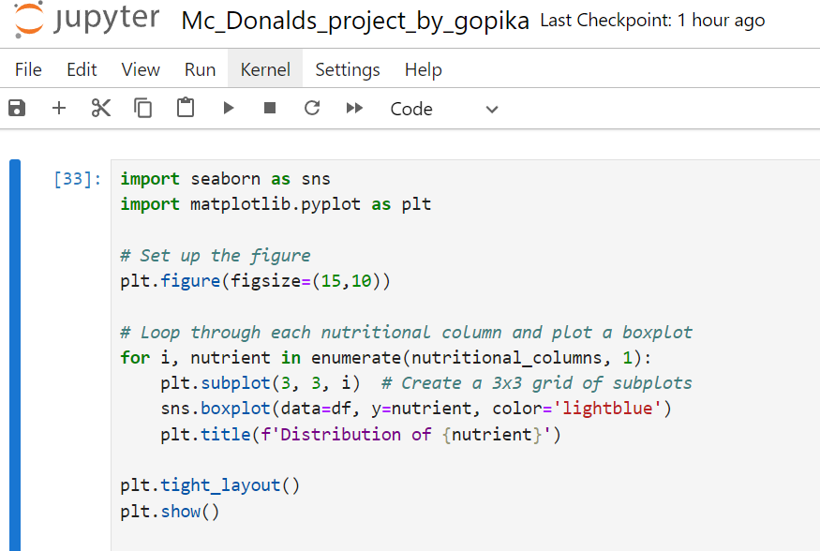

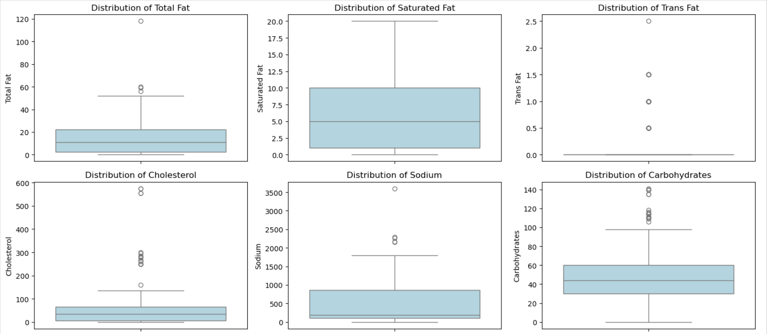

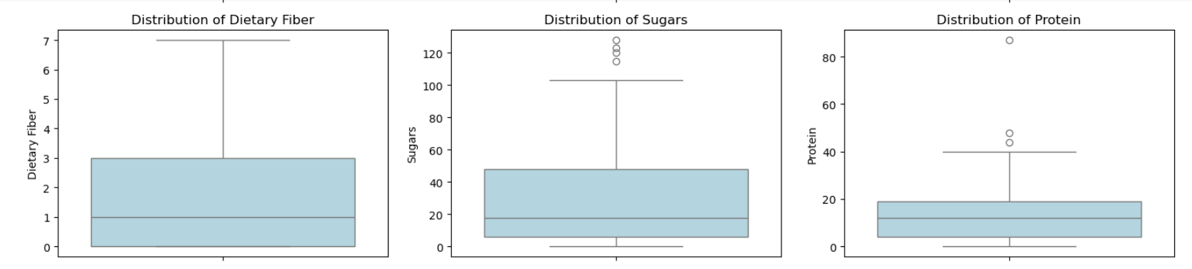

**Recommendations:**

* Introduce more fiber-rich and lower-sodium options.
* Promote items with moderate calorie and protein content to appeal to health-conscious consumers.
* Reassess the high-calorie and high-sugar items, especially in desserts and beverages, for potential reformulation or portion control to promote healthier eating habits.

1. **Heat Map Analysis**

The heatmap above visualizes the nutritional content of various McDonald's menu items, displaying values for key nutrients including Total Fat, Saturated Fat, Trans Fat, Cholesterol, Sodium, Carbohydrates, Dietary Fiber, Sugars, and Protein. The intensity of the colour represents the nutritional value, with darker shades indicating higher values and lighter shades representing lower values.

**Key Observations:**

1. Total Fat:

* Items High in Total Fat: Most breakfast items, such as Bacon, Egg & Cheese Biscuit and Sausage Biscuit with Egg, show darker shades, indicating higher total fat content.
* Beverages and Desserts: The drinks and desserts, such as Frappes and McFlurry, are relatively light in colour, suggesting lower fat content.

2. Saturated Fat:

* Items High in Saturated Fat: Similar to total fat, menu items like Big Breakfast with Hotcakes and Steak & Egg Biscuit are dense in saturated fats, with darker hues indicating higher saturated fat content.
* Healthier Items: Beverages, especially non-creamy drinks like Iced Coffee and Tea, show light colours, signalling low saturated fat levels.

3. Trans Fat:

* Minimal Trans Fat Content: Overall, the heatmap for Trans Fat is light, indicating minimal trans fat content across most items. A few breakfast and sandwich items have marginally higher trans fat, but none appear to be extreme outliers.
* Items of Concern: Trans fat levels are slightly higher in certain items like the Bacon, Egg & Cheese Biscuit.

4. Cholesterol:

* High Cholesterol Items: Darker shades indicate high cholesterol content in breakfast sandwiches and items with eggs, sausage, and bacon, such as Sausage Biscuit with Egg and Big Breakfast with Hotcakes.
* Lower Cholesterol Items: Beverages and side items like Fries and Fruit & Yogurt Parfait have lighter shades, indicating lower cholesterol levels.

5. Sodium:

* High Sodium Content: This nutrient shows the most alarming pattern, with darker shades indicating very high sodium levels in many items. Items such as Big Mac, Chicken McNuggets, and McWrap Chicken exhibit particularly high sodium content.
* Beverages & Desserts: Many drinks and desserts, such as Sundaes and Shakes, are low in sodium, as indicated by their lighter colours.

6. Carbohydrates:

* Carb-Rich Items: Items such as Hotcakes and Sausage, Frappes, and McFlurries show darker shades, indicating high carbohydrate content, mostly due to the sugar and starch in these items.
* Lower-Carb Items: Certain sandwiches and wraps, like McChicken and Grilled Chicken Salad, have lighter shades, indicating moderate to low carbohydrate content.

7. Dietary Fiber:

* Limited Fiber Content: The heatmap for Dietary Fiber is mostly light across all categories, indicating a general lack of fiber in most menu items. Even traditionally "healthier" options such as salads do not exhibit significant fiber content.
* Health Implication: Low dietary fiber levels may suggest that McDonald's menu could benefit from including more fiber-rich ingredients such as whole grains and vegetables.

8. Sugars:

* High-Sugar Items: Predictably, items like Frappes, Smoothies, and McFlurries show darker shades, reflecting their high sugar content.
* Low-Sugar Items: Savory items such as McChicken and Sausage Biscuits are low in sugar, shown by lighter colours.

9. Protein:

* Protein-Rich Items: Items such as Big Mac, Grilled Chicken Sandwich, and Egg McMuffin show darker shades, indicating that they are rich in protein.
* Lower Protein Items: Drinks and desserts like McFlurry and Smoothies have lighter shades, indicating they are low in protein content.

**Overall Nutritional Patterns:**

* High-Fat, High-Sodium Items: A clear pattern emerges showing that breakfast items, sandwiches, and chicken-related products tend to be high in both fat and sodium. These are key areas of concern, especially for consumers mindful of their heart health.
* Healthier Options: Certain items, such as salads and grilled chicken products, show a lighter shade in most categories, indicating that they may be healthier choices, particularly for those looking to limit fat, cholesterol, and sodium intake.
* High Sugar in Beverages: The high sugar content of desserts and beverages (like Frappes and Smoothies) stands out as an important takeaway, suggesting that consumers looking to reduce sugar intake should be cautious with these options.

**Recommendations:**

* Reducing Sodium and Fat: The high sodium and fat content in many menu items, particularly in breakfast offerings, could be reduced. Reformulating these items or introducing lower-sodium options could improve their healthfulness.
* Promote Fiber-Rich Options: Adding more fiber-rich items such as whole grain buns, additional vegetables, or fruit-based sides would provide customers with healthier alternatives and better-rounded nutritional options.
* Control Sugar in Beverages: Reducing the sugar content in beverages and desserts could help cater to a more health-conscious demographic.

**Appendix**

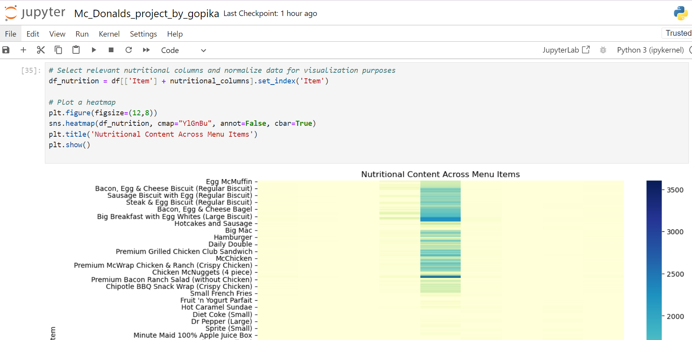

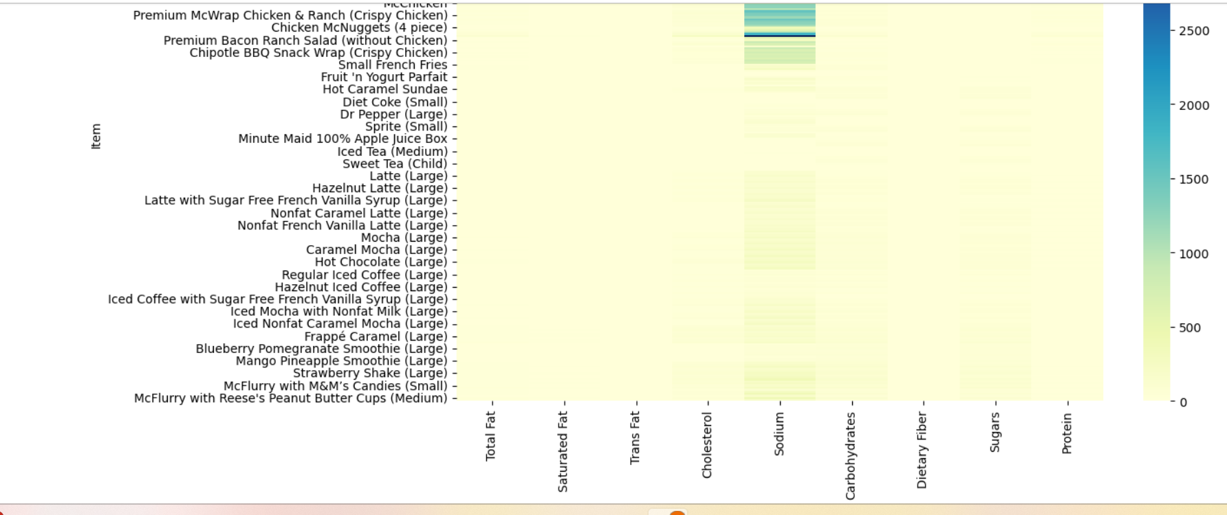

**Pairplot Analysis: Nutrient Relationships**

The pairplot visualizes the relationships between different nutritional variables for McDonald's menu items. Each plot provides a scatter matrix that highlights how these variables interact with one another, allowing us to observe potential correlations, clusters, and distribution trends across multiple nutrients. Below is an analysis of key insights derived from the visualization:

**1.** Total Fat and Saturated Fat:

* Strong Positive Correlation: There is a noticeable linear trend between Total Fat and Saturated Fat, indicating that menu items high in total fat are also likely to be high in saturated fat. This is not surprising since saturated fat is a component of total fat.
* Clustered Data: Most of the data points are clustered at lower levels of both fats, with a few outliers at higher levels, likely representing menu items such as certain burgers and breakfast items.

2. Total Fat and Cholesterol:

* Moderate Positive Correlation: There is a moderate positive trend between Total Fat and Cholesterol, suggesting that items with higher fat content also tend to have higher cholesterol. However, the relationship is not as strong as the one observed with saturated fat.
* Cholesterol Outliers: Several items with high cholesterol do not correspond to particularly high total fat, indicating that some items, particularly those with eggs or sausage, contribute more to cholesterol than fat.

3. Sodium and Cholesterol:

* Moderate Positive Correlation: There is a visible positive relationship between Sodium and Cholesterol, showing that higher sodium levels often accompany higher cholesterol. This is likely due to processed meats and fast-food preparation methods.
* High Sodium Items: There are notable high-sodium outliers, likely representing processed menu items such as chicken nuggets, fries, and burgers.

4. Total Fat and Sodium:

* Weak Positive Correlation: Although a positive trend is visible, the relationship between Total Fat and Sodium is relatively weak. This indicates that while many high-fat items are also high in sodium, this is not a universal rule across the menu.
* Wide Variation in Sodium: There are significant variations in sodium levels across items with both high and low fat, showing that some items, such as beverages and salads, may be low in fat but still contain high sodium levels.

5. Carbohydrates and Sugars:

* Strong Positive Correlation: As expected, there is a very strong correlation between Carbohydrates and Sugars, which is common in items high in refined sugars such as desserts, drinks, and sauces.
* Desserts & Beverages: Most of the higher carbohydrate values are attributed to sugar-rich items like McFlurries, Frappes, and Smoothies.

6. Protein and Total Fat:

* Moderate Positive Correlation: There is a moderate positive relationship between Protein and Total Fat, which suggests that menu items with higher protein content (such as burgers, chicken items, and breakfast sandwiches) also tend to have higher fat.
* Protein Outliers: Some high-protein items are relatively low in fat, such as grilled chicken options and salads with added protein, indicating healthier choices.

7. Dietary Fiber and Carbohydrates:

* Weak Positive Correlation: While there is a slight positive trend between Dietary Fiber and Carbohydrates, the relationship is not very strong. This suggests that while some high-carbohydrate items may contain fiber, many are likely composed of refined carbohydrates with little nutritional fiber.
* Low Fiber Content: Most menu items show low fiber content, which aligns with earlier insights from the heatmap, where fiber was generally low across the board.

8. Sugars and Total Fat:

* No Clear Correlation: There is no strong correlation between Sugars and Total Fat, which indicates that sugary items (desserts and beverages) tend to be separate from items high in fat (burgers, sandwiches). This means items like smoothies and shakes are high in sugar but not necessarily in fat.

9. Cholesterol and Protein:

* Positive Correlation: There is a positive relationship between Cholesterol and Protein, indicating that high-protein menu items tend to also be high in cholesterol. This trend is common in fast food due to the prevalence of animal-based proteins such as eggs, cheese, and meat.

**Appendix**

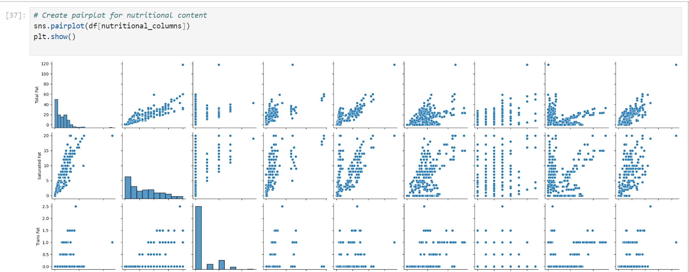

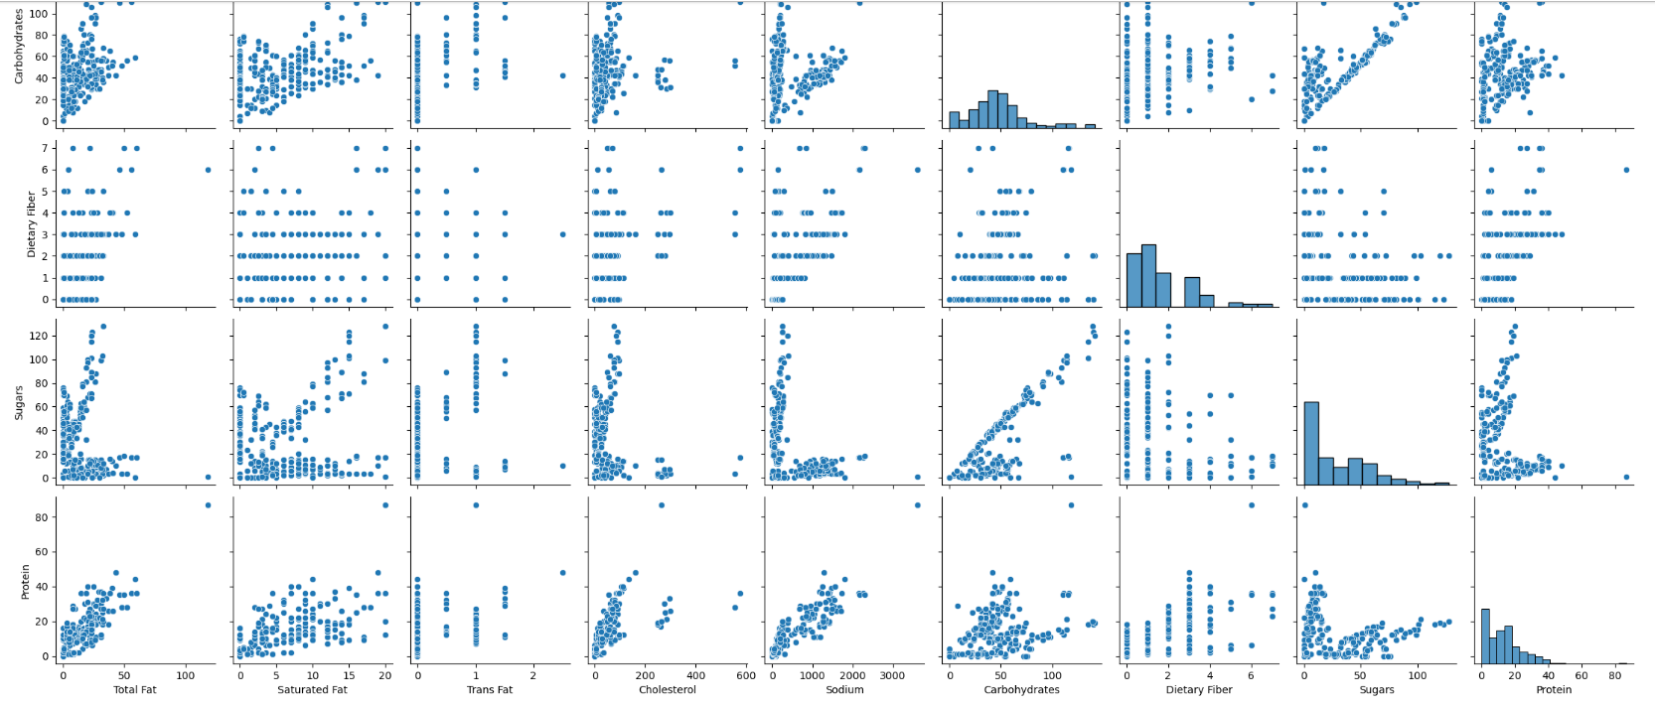

**Insights of Nutrient Relationships:**

* Key Strong Correlations: The strongest correlations are observed between Total Fat and Saturated Fat, Carbohydrates and Sugars, and Sodium and Cholesterol. These highlight the typical fast-food profile of high-fat, high-sodium, and high-sugar items.
* Protein Insights: While protein-rich items also tend to be high in fat and cholesterol, there are some healthier protein options (like grilled chicken) that provide a better nutritional balance.
* Sodium Awareness: Sodium levels across many items are high, but they do not necessarily correspond with higher fat or carbohydrate content, making sodium a nutrient of concern for a wide variety of menu items.

1. **Analysis of Top 10 McDonald's Menu Items by Protein Content**

The bar chart visualizes the top 10 McDonald's menu items ranked by their protein content. The items range from high-protein options like Chicken McNuggets (40 pieces) to various burgers and chicken sandwiches. Below is a detailed breakdown of the key insights:

**Key Findings:**

1. Highest Protein Content:
   * The Chicken McNuggets (40 piece) stands out as the menu item with the highest protein content by a significant margin compared to other items. It is likely a popular choice for customers seeking a high-protein meal, especially in larger portions.
   * This is followed by the Double Quarter Pounder with Cheese, which also provides a substantial amount of protein, making it the second-highest item in terms of protein content.
2. Chicken-Based Items Dominate:
   * Chicken McNuggets in different portion sizes (40 pieces, 20 pieces) occupy the first and third positions, showing that McDonald's chicken-based items are among the best sources of protein on the menu.
   * Other chicken-based items such as the Premium Grilled Chicken Club Sandwich and Bacon Clubhouse Grilled Chicken Sandwich also appear in the top 10 list, indicating that McDonald's grilled chicken options are solid choices for protein intake.
3. Beef-Based Items:
   * Several beef-based burgers are also prominent in the top 10, including the Double Quarter Pounder with Cheese, Bacon Clubhouse Burger, Quarter Pounder with Bacon & Cheese, and Quarter Pounder with Bacon Habanero Ranch. These burgers offer high protein due to their larger beef patties and added ingredients like bacon and cheese.
   * These options cater to customers who prefer beef but still seek high protein content in their meals.
4. Variety of Sandwiches:
   * McDonald's menu features a variety of high-protein sandwiches, including different variations of the Quarter Pounder and the Premium McWrap Chicken & Bacon. This variety suggests that McDonald's offers a broad range of high-protein options, catering to different customer preferences (grilled chicken vs. beef-based burgers).
5. Bacon-Enhanced Protein Content:
   * Several of the top 10 items, such as the Quarter Pounder with Bacon & Cheese, Bacon Clubhouse Burger, and Bacon Clubhouse Grilled Chicken Sandwich, include bacon, which enhances the protein content of these sandwiches. The presence of bacon in these items is likely contributing to their high ranking in the list.

**Appendix**

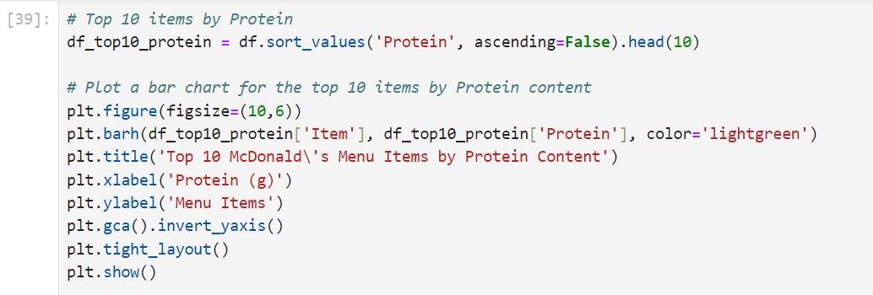

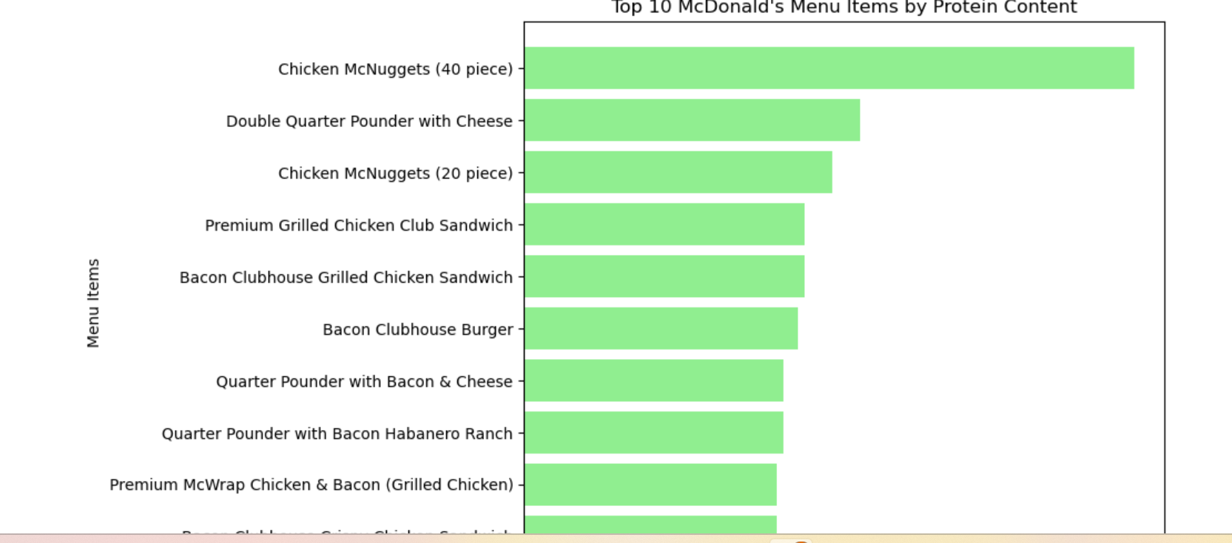

**Insights for Health-Conscious Customers:**

1. High Protein Options:
   * Customers looking for high-protein meals can opt for the Chicken McNuggets (40 pieces) or the Double Quarter Pounder with Cheese, both of which offer substantial protein content. However, larger portion sizes should be consumed with caution, as they are likely to be higher in calories, fat, and sodium as well.
2. Grilled Chicken Sandwiches:
   * The Premium Grilled Chicken Club Sandwich and Bacon Clubhouse Grilled Chicken Sandwich provide high protein while potentially offering a healthier alternative to burgers. These sandwiches may be preferable for customers seeking leaner protein sources.
3. Balanced Nutritional Choices:
   * While these items rank highly in terms of protein content, customers should consider the overall nutritional profile, including the fat, calorie, and sodium content, especially with large portion items like the Double Quarter Pounder with Cheese and Chicken McNuggets (40 piece).

**Recommendations:**

1. Promote High-Protein Options:
   * McDonald's can emphasize and market these high-protein options to attract fitness-conscious or health-conscious customers who prioritize protein in their meals.
2. Healthier High-Protein Alternatives:
   * Introducing more grilled chicken and leaner protein-based options could cater to customers who want high-protein meals without excessive calories, fat, or sodium.
3. Portion Control Awareness:
   * Encouraging portion control by promoting smaller servings of high-protein items (such as the 20-piece Chicken McNuggets instead of the 40-piece) could help customers maintain a balanced diet while still benefiting from high protein intake.

1. **Correlation Matrix Analysis: Nutritional Content**

**Key Insights and Interpretation:**

1. Total Fat

* Highly Correlated With Saturated Fat (0.85): There is a strong positive correlation between Total Fat and Saturated Fat. This suggests that items high in total fat are also likely to have high saturated fat content. It indicates that much of the fat in McDonald’s menu items comes from saturated sources.
* Correlation with Protein (0.81): There is a strong positive correlation between Total Fat and Protein, implying that items higher in protein, such as burgers and chicken sandwiches, also tend to be higher in fat.
* Correlation with Sodium (0.85): The high correlation between Total Fat and Sodium indicates that items with higher fat content also tend to be high in sodium, which is a typical characteristic of fast-food products.

2. Saturated Fat

* Moderate Correlation with Cholesterol (0.63): Items with higher saturated fat content tend to have moderately higher cholesterol levels. This is expected, as cholesterol is often found in foods high in saturated fats, especially those containing animal products.
* Moderate Correlation with Sodium (0.58): There is a moderate positive correlation between Saturated Fat and Sodium, suggesting that many high-fat items are also likely to have high sodium content.

3. Trans Fat

* Weak Correlation with Other Nutrients: Trans Fat shows relatively weaker correlations across most nutrients, with a maximum correlation of 0.62 with Saturated Fat. This may indicate that while trans fats are present in some items, they are not a major contributor to the overall fat content in McDonald’s menu.

4. Cholesterol

* Moderate Positive Correlation with Sodium (0.62): Items higher in Cholesterol are moderately associated with higher sodium levels, which is common in fast-food items that include animal products like eggs, cheese, and meat.
* Correlation with Protein (0.56): A moderate positive correlation between Cholesterol and Protein suggests that high-protein items like burgers and breakfast sandwiches also tend to have higher cholesterol content.

5. Sodium

* Highly Correlated with Total Fat (0.85) and Protein (0.87): Sodium shows strong correlations with both Total Fat and Protein, meaning that items high in sodium, such as burgers and sandwiches, tend to have higher fat and protein content. This is characteristic of processed meats and fried products, which are high in sodium.
* Negative Correlation with Sugars (-0.43): There is a moderate negative correlation between Sodium and Sugars, indicating that sugary items such as desserts and beverages are likely to be lower in sodium content.

6. Carbohydrates

* High Correlation with Sugars (0.76): There is a very strong positive correlation between Carbohydrates and Sugars, as expected. Many of the high-carb items on McDonald’s menu, such as desserts and drinks, derive their carbohydrates primarily from sugars.
* Low Correlation with Total Fat (-0.46): A moderately negative correlation between Carbohydrates and Total Fat suggests that carbohydrate-rich items, such as fries and desserts, are lower in fat compared to protein-rich or fried menu items.

7. Dietary Fiber

* Weak Correlation Across Nutrients: Dietary Fiber shows weak to moderate correlations across other nutrients, with the highest correlation being 0.69 with Sodium. This implies that although fiber is present, it doesn't strongly relate to high-fat or high-sodium items. Low fiber levels across most fast-food items are common trend.
* Negative Correlation with Sugars (-0.30): There is a weak negative correlation between Dietary Fiber and Sugars, which indicates that items high in sugar, such as beverages, tend to have low or no fiber content.

8. Sugars

* High Correlation with Carbohydrates (0.76): Sugars show a strong correlation with carbohydrates, indicating that sugary items, such as beverages and desserts, are high in carbohydrates.
* Negative Correlation with Sodium (-0.43): Items high in sugar, such as desserts and beverages, tend to have lower sodium content compared to savoury items like burgers and fries.

9. Protein

* Strong Positive Correlation with Total Fat (0.81): This shows that menu items with higher protein content, such as chicken sandwiches, burgers, and nuggets, are also higher in fat.
* Moderate Correlation with Sodium (0.87): Protein-rich items tend to be high in sodium, which is typical of processed meats used in fast food.
* Negative Correlation with Sugars (-0.18): Protein and sugar content have a weak negative correlation, showing that protein-rich items tend to be low in sugar, while sugary items, like desserts and beverages, are low in protein.

**Appendix**



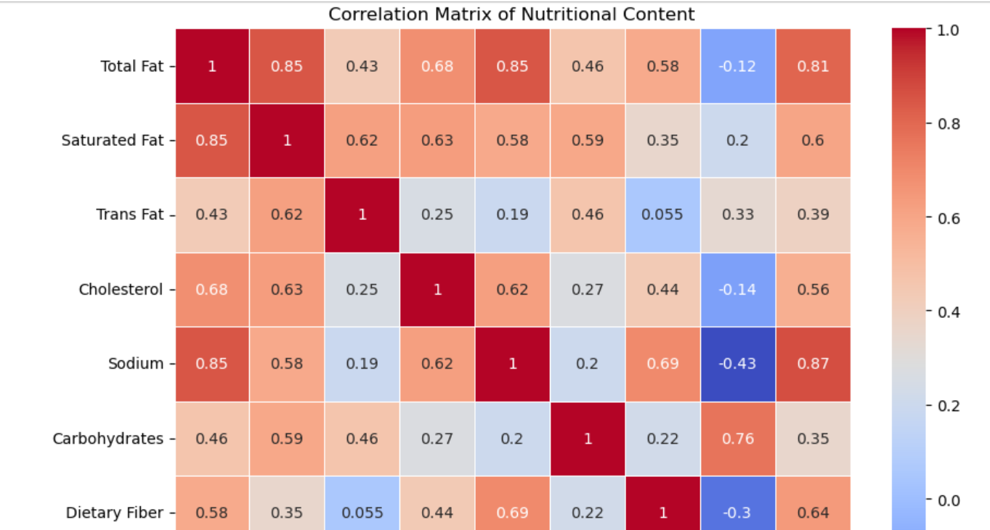

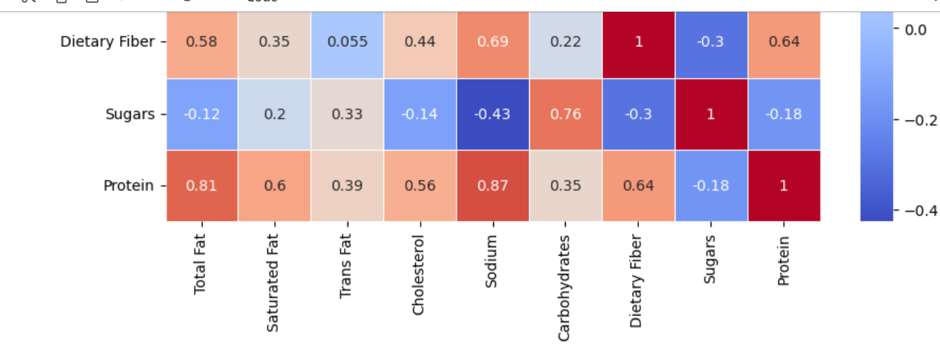

**Recommendations:**

* Reduce Sodium in High-Protein Items: The strong correlation between sodium and protein indicates a potential area for improvement, as reducing sodium in high-protein items could help make these menu options healthier.
* Increase Fiber Content: Given the weak correlation between dietary fiber and other nutrients, McDonald’s could enhance the nutritional profile of its menu by introducing more fiber-rich options, particularly in low-fiber items like burgers and sandwiches.
* Monitor Fat and Saturated Fat Levels: The strong relationship between total fat and saturated fat suggests that menu items high in fat are also high in unhealthy saturated fats. Reformulating recipes to reduce saturated fat could improve the overall healthiness of these items.

1. **Analysis of Top 10 McDonald's Menu Items by Total Fat Content**

The bar chart illustrates the top 10 McDonald's menu items ranked by their total fat content. This analysis highlights which items on the menu contribute the most fat, with an emphasis on portion sizes and breakfast options. Below is a detailed analysis of the chart:

**Key Observations:**

1. Highest Fat Content:
   * Chicken McNuggets (40 piece) holds the top spot for the highest total fat content by a significant margin. Given its large portion size, this result is expected. This is an indication that large portions of fried items like nuggets contribute heavily to fat intake.
2. Breakfast Items Dominate:
   * Out of the top 10 items, the majority are breakfast meals, including variations of the Big Breakfast with Hotcakes and Big Breakfast with Biscuits.
   * These breakfast meals include multiple components (e.g., eggs, sausage, biscuits, hotcakes), contributing to higher total fat content due to their combination of processed meats, fried foods, and pastries.
3. Variation in Biscuit and Portion Sizes:
   * The Big Breakfast appears multiple times in the list, differing slightly in portion size (e.g., Large Biscuit vs. Regular Biscuit) or inclusion of specific components (e.g., Hotcakes and Egg Whites).
   * The variation in serving sizes and additional items (such as hotcakes or regular/large biscuits) impacts the overall fat content, with larger portions expectedly contributing more fat.
4. Double Quarter Pounder with Cheese:
   * The Double Quarter Pounder with Cheese is the only non-breakfast item to appear in this list. This large beef burger, combined with cheese and other toppings, contributes significantly to the total fat content.
   * Given its size and ingredients (two beef patties, cheese, sauces), it is no surprise that this burger ranks in the top 10 for fat content.

**Nutritional Insights:**

1. Fried and Processed Ingredients:
   * The high fat content in many of these menu items can be attributed to fried foods (such as nuggets) and processed meats (like sausage), which are common components of McDonald's meals.
   * Biscuits and pastries, which are prevalent in the breakfast meals, are often made with butter or oil, contributing additional fat.
2. Portion Size Impact:
   * Portion size plays a significant role in the fat content of these items. Larger serving sizes, such as the 40-piece Chicken McNuggets and the Big Breakfast with Hotcakes, contribute far more fat than smaller portions.
   * For customers seeking to manage their fat intake, smaller portion sizes would be advisable.
3. Potential for Healthier Options:
   * Grilled options, which are absent from this list, typically contain lower fat content than their fried counterparts. Encouraging customers to opt for grilled items instead of fried ones could help reduce their fat intake.

**Appendix**

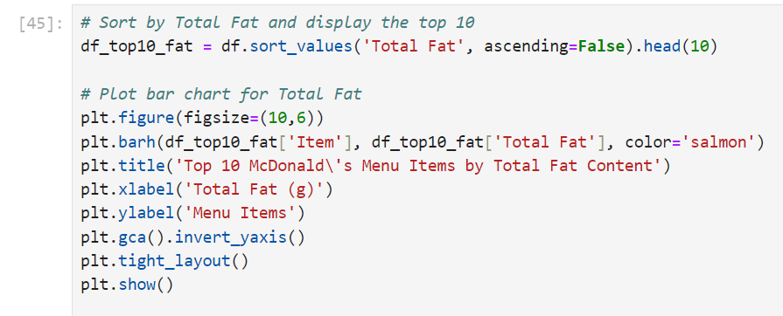

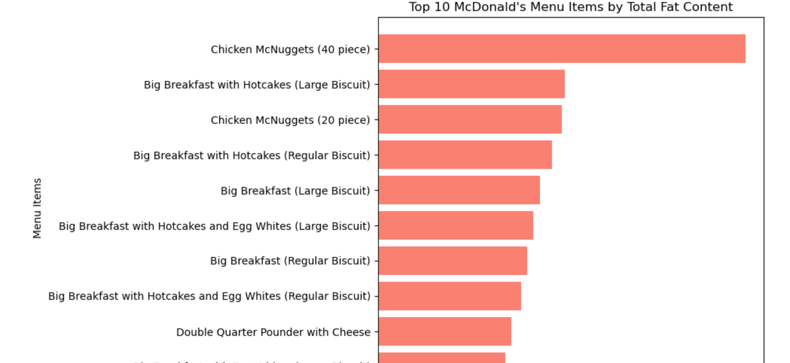

**Recommendations:**

1. Portion Control Options:
   * Providing customers with the option to choose smaller portion sizes for high-fat items like Chicken McNuggets could help in reducing fat intake while still enjoying these popular items.
2. Healthier Breakfast Alternatives:
   * Since many high-fat items are breakfast meals, McDonald's could introduce or promote healthier breakfast alternatives, such as egg whites, fruit, or whole-grain options. Reducing or eliminating sausage and biscuit components could also make these meals healthier.
3. Highlighting Nutritional Information:
   * Clear labelling of fat content in promotional materials or menu boards could help customers make more informed decisions, particularly when ordering high-fat items like the Big Breakfast and Double Quarter Pounder with Cheese.
4. **Caloric Trends: Analysis of Average Calories per Food Category**

The bar chart visualizes the average calories across different food categories on the McDonald's menu. It provides an insightful comparison of how caloric content varies between items such as beef & pork, breakfast, chicken & fish, salads, beverages, desserts, snacks, and sides.

**Key Observations:**

1. Highest Caloric Categories:
   * Chicken & Fish and Breakfast categories contain the highest average calorie content, with values exceeding 500 calories per item.
     + Chicken & Fish items likely include fried options like chicken sandwiches and Filet-O-Fish, which are higher in fat and carbohydrates.
     + Breakfast meals likely include items like Big Breakfasts and Sausage McMuffins, which contain high-calorie ingredients such as eggs, sausages, and biscuits, contributing to their high caloric value.
2. Beef & Pork:
   * Beef & Pork also show a relatively high average caloric content, close to 500 calories per item. This is due to burgers and beef-based sandwiches, which typically contain multiple high-calorie components (e.g., beef patties, cheese, bacon).
   * Items such as the Quarter Pounder and Big Mac are examples of high-calorie options in this category.
3. Salads:
   * Surprisingly, Salads have a relatively moderate average calorie count, similar to snacks & sides, hovering around 300 calories. This could be due to added ingredients like dressing, chicken, or cheese, which significantly raise the calorie content of otherwise low-calorie salad ingredients.
   * While salads are generally perceived as healthy, the additional toppings and dressings may contribute to the higher calorie count.
4. Lowest Calorie Categories:
   * Beverages and Desserts have the lowest average calorie content, with beverages being the lowest. Items like iced tea or coffee without added sugar or cream likely contribute to the low average.
   * Desserts show lower caloric averages compared to main meal items, but there is a possibility that smaller portioned items like cookies or ice creams are contributing to this.
5. Coffee & Tea:
   * Coffee & Tea show a moderate average caloric content, likely due to added sugar, milk, cream, or syrups in some beverages (like lattes and frappes). These additives can increase the calorie count, pushing some beverages into higher caloric ranges compared to plain coffee or tea.
6. Snacks & Shakes:
   * Shakes contribute significantly to the overall high-calorie count in the Snacks & Shakes category, with an average approaching 500 calories. Shakes are typically high in sugar, fat, and dairy content, which results in their high-calorie count.

**Insights and Implications:**

1. High-Calorie Meal Options:
   * The Chicken & Fish, Breakfast, and Beef & Pork categories contain the highest calorie options, making them less suitable for customers seeking low-calorie meals. These categories include fried items, processed meats, and breakfast combinations that add up to a high-calorie meal.
2. Health-Conscious Choices:
   * Customers aiming for a lower-calorie meal may want to explore items in the Beverages, Desserts, or Salads categories. However, they should be mindful of hidden calories in dressings or beverage additives like syrups and cream.
3. Breakfast and Chicken/Fish:
   * The Breakfast category offers some of the highest-calorie items on the menu. While breakfast is important for fueling the day, these items can contribute to high calorie and fat intake if consumed regularly.
   * The Chicken & Fish category also contains calorie-dense items, likely due to frying and breading. Grilled options would likely offer a lower-calorie alternative.
4. Beverages and Desserts:
   * While Beverages and Desserts have lower average calorie counts compared to main meal items, high-sugar beverages (such as milkshakes) and desserts (such as pies) should still be consumed in moderation to avoid excess sugar intake.

**Appendix**

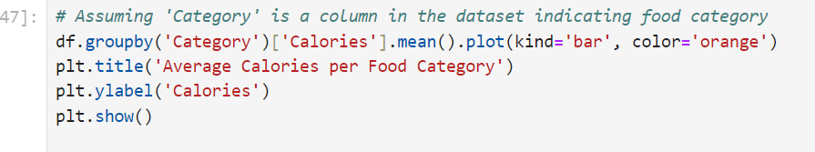

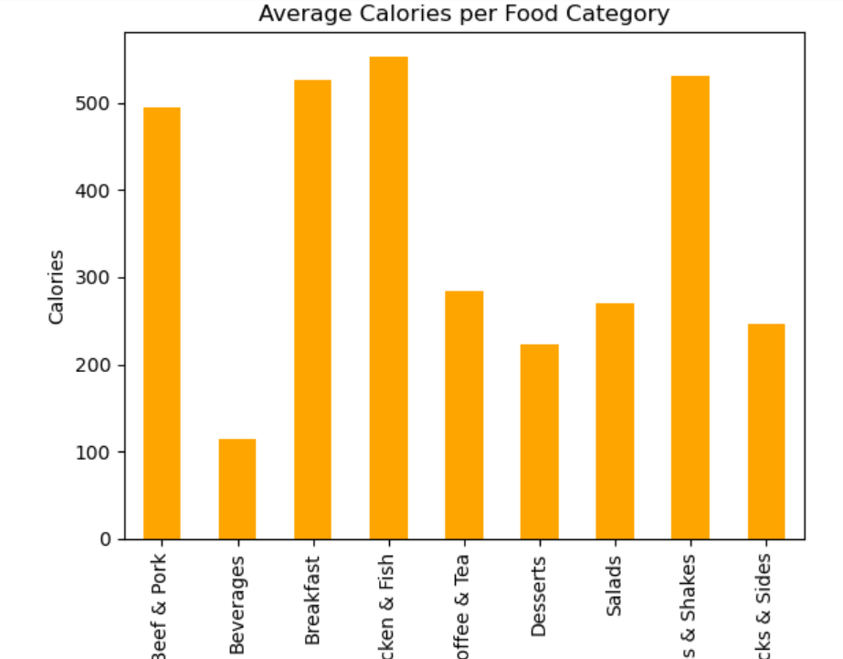

**Recommendations :**

1. Healthier Alternatives:
   * McDonald’s could consider offering healthier, lower-calorie alternatives for popular categories like Breakfast, Chicken & Fish, and Beef & Pork. Reducing portion sizes or offering grilled items could help reduce the overall caloric content.
2. Portion Control for High-Calorie Items:
   * Items in the Shakes and Snacks category could benefit from offering smaller portion sizes, as their high caloric content is concerning for customers mindful of sugar and fat intake.
3. Promote Healthier Beverages:
   * Emphasizing low-calorie beverage options, such as unsweetened tea or black coffee, could help customers reduce their calorie intake while still enjoying their favourite drinks.
4. **Nutritional Content Trends: Analysis of Nutritional Breakdown of Top 10 High-Calorie Menu Items**

This bar chart visualizes the nutritional breakdown of the top 10 McDonald’s menu items based on their caloric content. Each bar represents a different menu item, and the colors in each bar correspond to key nutrients, including Total Fat, Carbohydrates, Protein, Sodium, and Sugars. Below is a detailed analysis of the trends shown in the chart:

**Key Observations:**

1. Chicken McNuggets (40 pieces) – Extremely High Caloric Content:
   * Total Calories: The 40-piece Chicken McNuggets stands out as the highest-calorie item by a large margin, with total fat (blue) and protein (green) being the dominant components.
   * Sodium (Red): Sodium content is also exceptionally high, reflecting the processed and fried nature of the nuggets. Customers consuming this portion size will likely exceed recommended daily limits for sodium and fat intake.
2. Big Breakfast with Hotcakes (Multiple Variations):
   * Several variations of the Big Breakfast with Hotcakes occupy the next positions. These items are particularly high in total fat and sodium, with significant contributions from carbohydrates due to the hotcakes and biscuits.
   * Carbohydrates (Orange): Hotcakes, biscuits, and syrups contribute heavily to the carbohydrate content. This makes breakfast one of the highest-calorie meals offered on the McDonald's menu.
   * The presence of eggs, sausage, and biscuits explains the significant levels of both protein and sodium in these meals.
3. Chicken McNuggets (20 pieces):
   * The 20-piece Chicken McNuggets also ranks high, though it has roughly half the caloric content of the 40-piece option. Like its larger counterpart, it is high in fat, sodium, and protein, representing a nutritionally dense but calorie-heavy option.
4. Desserts and Shakes:
   * The final group includes several dessert options: McFlurry with M&M’s Candies (Medium), Chocolate Shake (Large), Strawberry Shake (Large), and Shamrock Shake (Large).
   * Sugars (Purple): These desserts are primarily composed of sugars, with carbohydrates dominating the nutritional profile. Fat and protein are present in smaller quantities.
   * Calories from Sugars: These items, especially the shakes, derive most of their calories from added sugars, which explains their lower fat and protein content relative to the breakfast and nugget options.

**Nutritional Content Trends:**

1. High Fat and Sodium Content:
   * The Chicken McNuggets (both 40 and 20 pieces) and Big Breakfast with Hotcakes variations are not only high in calories but are also packed with sodium and fat. These two nutrients are common in processed and fried foods, and customers consuming these items may be at risk of exceeding daily recommendations for fat and sodium.
2. Protein Contribution:
   * Protein content is relatively high for items like Chicken McNuggets and Big Breakfast meals, largely due to the presence of eggs, sausage, and chicken. Protein, while essential, is accompanied by large quantities of fat and sodium, making these items less balanced than healthier options like grilled chicken or salads.
3. Carbohydrate-Heavy Shakes and Desserts:
   * The McFlurry and Shakes contain very high levels of carbohydrates, driven primarily by sugars. These items, while high in sugar, do not offer significant nutritional benefits such as protein or fiber and are calorically dense with little satiety value.
   * These sugary items could contribute to weight gain if consumed frequently, as they provide high energy but do not offer a balance of nutrients.

**Appendix**

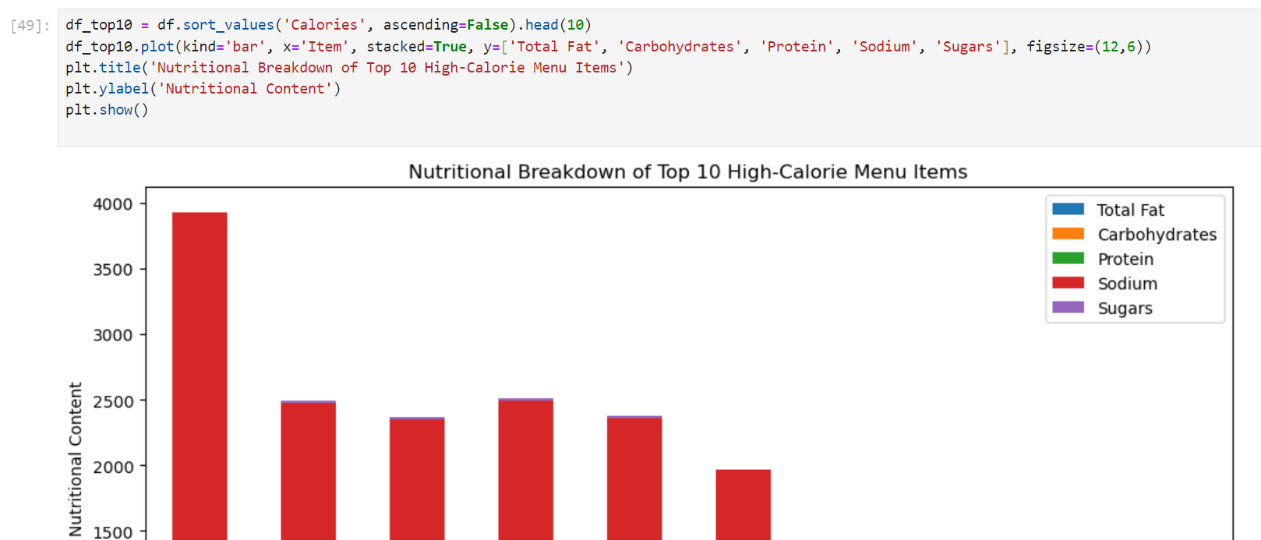

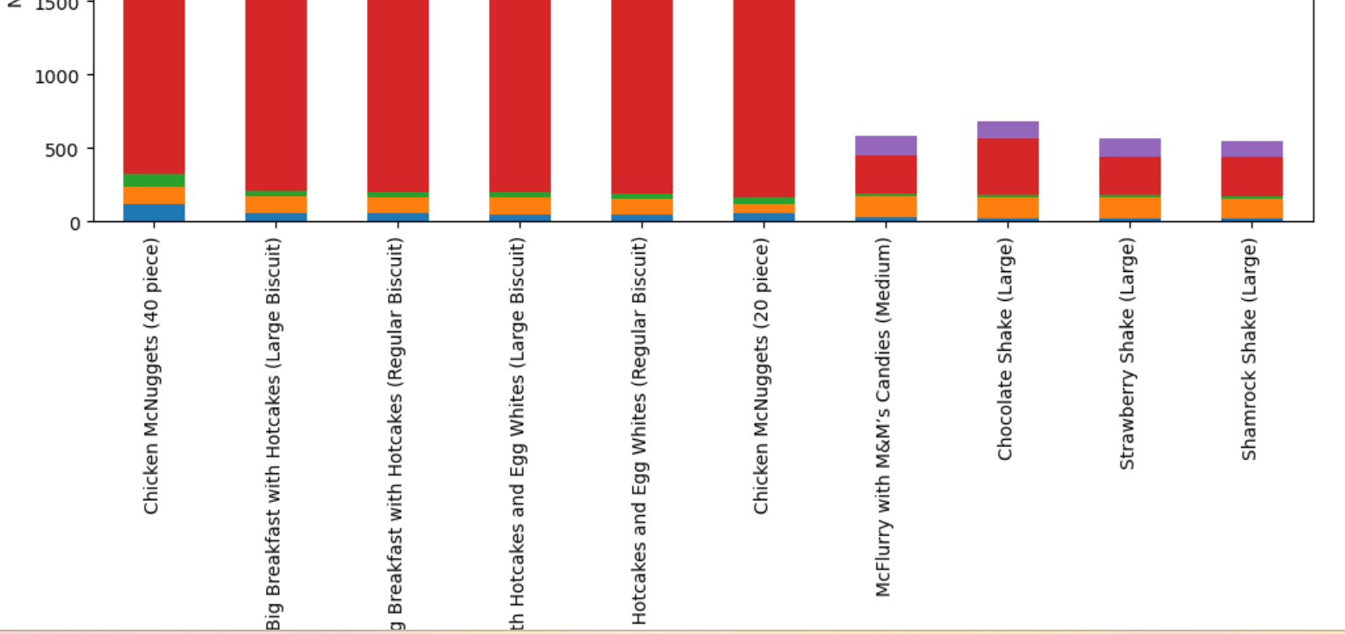

**Health Considerations:**

1. Excess Sodium and Fat Intake:
   * Consuming the Chicken McNuggets (40-piece) or any variation of the Big Breakfast with Hotcakes provides excessive sodium and fat. These items should be consumed in moderation, especially for individuals monitoring their salt and fat intake for heart health or blood pressure control.
2. Caloric Density in Desserts and Shakes:
   * The McFlurry and Shakes offer high-calorie content with little nutritional value outside of sugar and carbohydrates. They are energy-dense, and overconsumption can contribute to obesity, diabetes, and other metabolic disorders if not managed carefully.
3. Portion Control:
   * Given that portion size plays a significant role in caloric content, customers should be aware of how larger portions (e.g., 40-piece McNuggets or Large Shakes) drastically increase the intake of unhealthy nutrients like fat, sodium, and sugar.

**Recommendations :**

1. Portion Awareness and Alternatives:
   * Offering smaller portion sizes or promoting smaller meals could help customers manage their intake of calories, fat, and sodium. Offering grilled chicken options as an alternative to fried McNuggets would provide a healthier high-protein option.
2. Healthier Breakfast Alternatives:
   * Introducing or promoting lighter breakfast options, such as fruit or oatmeal, could provide customers with a nutritious start to the day without the excessive calorie, fat, and sodium content found in items like the Big Breakfast with Hotcakes.
3. Reduce Sugar in Shakes and Desserts:
   * Lowering the sugar content in the McFlurry and Shakes or offering reduced-sugar alternatives would allow McDonald's to cater to more health-conscious consumers.
4. **Analysis of Average Nutritional Content by Food Category**

* The bar chart provides a comparison of average nutritional content across various food categories on the McDonald's menu. The nutrients compared include Total Fat (blue), Protein (orange), Carbohydrates (green), and Sugars (red). Each category shows how these key nutritional values vary across McDonald's menu items. Below is an analysis of the trends and insights derived from this chart:

**Key Observations:**

Beef & Pork:

* High in Protein and Fat: Items in this category, which likely include burgers and other beef or pork-based products, are high in Protein and Total Fat. The fat content (around 40 grams) is notable, and protein content is relatively high, making these items more calorie-dense.
* Moderate in Carbohydrates: Carbohydrate content is lower than in other categories, suggesting that these items are protein- and fat-heavy rather than carb-heavy.

Beverages:

* Low in Protein, Fat, and Sugars: Beverages appear to have a minimal amount of Protein, Total Fat, and Sugars, indicating that unsweetened beverages such as tea and coffee contribute little in terms of calories and macronutrients. However, this may not include sugar-laden beverages like sodas and milkshakes.

Breakfast:

* High in Protein, Fat, and Carbohydrates: Breakfast items show high levels of Total Fat and Protein, with carbs also being substantial. This likely comes from items like egg-and-sausage-based breakfasts or breakfast sandwiches. Sugars are present but in lower quantities compared to other categories, suggesting that breakfast items are more savoury than sweet.

Chicken & Fish:

* Balanced Nutrient Content: Items in this category (likely including chicken sandwiches, grilled chicken, and fish-based products like the Filet-O-Fish) offer a balanced combination of Protein, Total Fat, and Carbohydrates. Carbohydrates are slightly higher, likely due to breading or bun components.

Coffee & Tea:

* Minimal Nutritional Content: Similar to Beverages, the Coffee & Tea category is low in Total Fat, Protein, and Sugars, indicating that plain versions of these drinks are not nutritionally dense. However, sugar and carb-heavy additions like flavored syrups could skew this for specific items.

Desserts:

* High in Sugars and Carbohydrates: Unsurprisingly, desserts are characterized by very high Carbohydrates and Sugars, with minimal Protein and Fat. Desserts contribute heavily to sugar intake, which is a major factor in their calorie content.

Salads:

* Moderate Protein and Low Fat: Salads provide a good source of Protein without being excessively high in fat. This suggests that some salads include chicken or other protein-rich toppings while avoiding heavy use of fat. Carbohydrates and sugars remain relatively low, making this a healthy option.

Smoothies & Shakes:

* Very High in Carbohydrates and Sugars: This category has the highest sugar content among all food categories, with Carbohydrates also being substantial. Smoothies and shakes are typically sugar-heavy and can contribute significantly to a person's daily calorie intake without much nutritional benefit from fat or protein.

Snacks & Sides:

* Balanced Nutrients: Snacks and sides show moderate amounts of Fat, Carbohydrates, and Sugars, likely including items like fries, apple slices, and small snacks. While not as heavy as full meals, they contribute to overall caloric intake.

**Appendix**

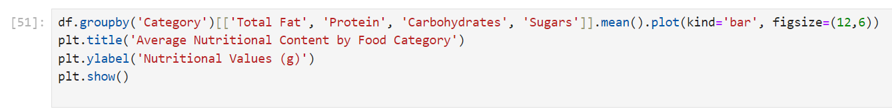

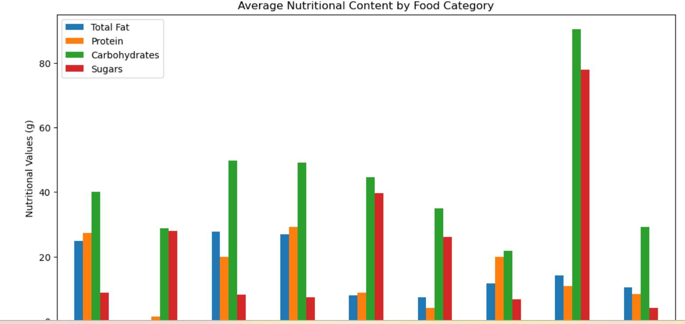

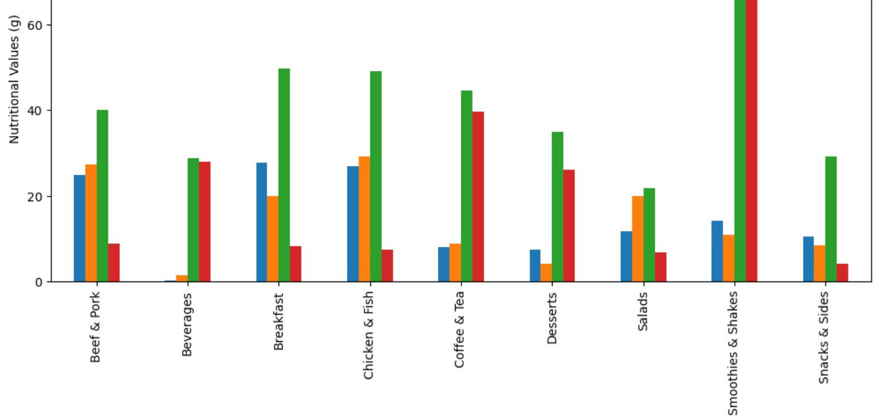

**Insights and Implications:**

High Fat and Protein Categories:

* Categories like Beef & Pork and Breakfast contribute heavily to both Fat and Protein intake. These items are likely energy-dense but may also be high in unhealthy fats, depending on the specific items consumed.

Sugar-Dense Categories:

* Desserts and Smoothies & Shakes are predominantly composed of Sugars and Carbohydrates, making them highly calorific without offering significant amounts of protein or healthy fats. Overconsumption of these items could lead to high sugar intake, which is a concern for individuals managing blood sugar levels or those looking to reduce sugar consumption.

Balanced Options:

* The Chicken & Fish and Salads categories offer more balanced nutrient profiles, making them better choices for those looking for high-protein, moderate-fat, and lower-sugar meals. These categories are ideal for health-conscious customers seeking a balanced macronutrient intake.

Beverages and Coffee/Tea:

* Beverages and Coffee/Tea are low in most macronutrients, making them low-calorie options. However, this does not account for sugar-heavy additions like syrups, which could drastically alter the nutritional profile of these items.

**Recommendations :**

Promote Healthier Categories:

* McDonald’s could highlight and promote the more balanced options in the Chicken & Fish and Salads categories, which provide moderate fat and high protein without excess sugar or unhealthy fats.

Reduce Sugar in Desserts and Shakes:

* Given the high sugar content in Desserts and Smoothies & Shakes, offering lower-sugar alternatives or smaller portions could cater to health-conscious customers while reducing unnecessary sugar intake.

Increase Low-Calorie Beverage Options:

* As Beverages and Coffee & Tea offer low-calorie choices, McDonald’s could promote unsweetened versions of these drinks or encourage customers to customize drinks with less sugar or cream.

**4. Category Trends:**

* **Fast food vs. beverages**: You can look for patterns between different categories like burgers, sides, desserts, and drinks. Do beverages have significantly different patterns in nutritional values (e.g., low protein, high sugar)?

**5. Outliers:**

* **Identify outliers**: Some menu items might stand out in terms of extremely high or low nutritional values (like sodium or sugar). Outliers can often represent either very unhealthy or surprisingly healthy choices.

**6. Nutritional Diversity:**

* **Nutrient variability**: You might want to assess how much variability there is between menu items regarding nutrients like carbohydrates, sugars, and fats. High variability suggests that there’s a wide range of nutritional values, allowing consumers to make healthier or unhealthier choices.

**Insights You Could Derive:**

* **Calorie Distribution**: You can see whether calories are clustered around certain values (e.g., high-calorie burgers, low-calorie salads).
* **Nutritional Balance**: Compare which food categories have high levels of protein, fat, or carbohydrates.
* **Outliers**: Box plots can help you identify unusually high or low-calorie items within a category.

1. **Menu Items with the Highest and Lowest Calorie Counts**

To identify the items with the highest and lowest calorie counts, sorted the dataset based on the "Calories" column.

**Appendix**

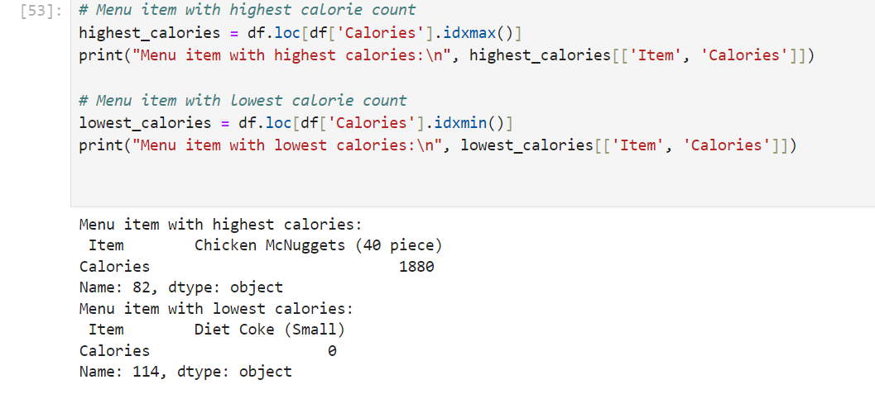

1. **Analysis of Average Nutritional Content of Popular Menu Categories**

The below table summarizes the average nutritional content of various popular food categories from McDonald’s menu. The data includes values for key nutrients such as Calories, Total Fat, Carbohydrates, Protein, Sugars, and Sodium. Below is a detailed analysis of each category based on the provided information:

1. Beef & Pork:

* Calories: 494 kcal
* Total Fat: 24.87g
* Carbohydrates: 40.13g
* Protein: 27.33g
* Sugars: 8.8g
* Sodium: 1020.67mg

Key Insights:

* High Protein: This category is high in protein, which is expected given the nature of beef and pork-based products like burgers and sandwiches.
* High Sodium: Sodium content is particularly high at 1020.67mg, indicating that items in this category contribute significantly to daily salt intake. This is typical for processed meats and fast-food items.
* Moderate Fat and Carbohydrates: Total Fat and Carbohydrates are relatively balanced, but the combination with high sodium makes these items less healthy for regular consumption.

2. Beverages:

* Calories: 113.7 kcal
* Total Fat: 0.09g
* Carbohydrates: 28.81g
* Protein: 1.33g
* Sugars: 27.85g
* Sodium: 41.48mg

Key Insights:

* High Sugar Content: The main contributor to the caloric content in this category is sugar. Beverages, especially sugary drinks, can be high in sugars, which should be consumed in moderation.
* Minimal Fat and Protein: Beverages provide negligible amounts of fat and protein, making them low in overall nutritional value apart from sugar.
* Low Sodium: Sodium content is low, which is typical of beverages.

3. Breakfast:

* Calories: 526.67 kcal
* Total Fat: 27.69g
* Carbohydrates: 49.76g
* Protein: 19.86g
* Sugars: 8.26g
* Sodium: 1211.07mg

Key Insights:

* High in Calories, Fat, and Sodium: Breakfast items are calorically dense and typically high in fat and sodium. This is likely due to ingredients like sausage, eggs, and biscuits.
* Balanced Protein: Breakfast items offer a reasonable amount of protein due to the inclusion of egg and meat-based ingredients.
* High Sodium: Sodium is significantly high at 1211.07mg, which could exceed daily recommendations in just one meal.

4. Chicken & Fish:

* Calories: 552.96 kcal
* Total Fat: 26.96g
* Carbohydrates: 49.07g
* Protein: 29.11g
* Sugars: 7.33g
* Sodium: 1257.78mg

Key Insights:

* High Protein: As expected, the Chicken & Fish category is high in protein, making these items good sources of lean muscle-building nutrients.
* High Sodium: With sodium levels at 1257.78mg, this category contains significant amounts of salt, likely due to processed and fried items like chicken sandwiches and fish fillets.
* Balanced Fat and Carbohydrates: There is a balance between fat and carbs, but the high sodium levels make these items less ideal for frequent consumption.

5. Coffee & Tea:

* Calories: 283.89 kcal
* Total Fat: 8.02g
* Carbohydrates: 44.53g
* Protein: 8.86g
* Sugars: 39.61g
* Sodium: 136.89mg

Key Insights:

* High in Sugars: Coffee and tea drinks often contain added sugars and syrups, contributing to the 39.61g of sugar in this category. This is a concern for those monitoring their sugar intake.
* Low in Protein and Fat: These items have minimal protein and moderate fat content, primarily coming from added creams or milk.
* Moderate Sodium: Sodium levels are fairly low, but sugar content should be closely monitored.

6. Desserts:

* Calories: 222.14 kcal
* Total Fat: 7.36g
* Carbohydrates: 34.86g
* Protein: 4g
* Sugars: 26.14g
* Sodium: 117.14mg

Key Insights:

* High Sugar Content: Desserts are dominated by sugars, contributing to a high sugar content of 26.14g per serving. While calories are relatively low, most come from sugar.
* Low Protein: Protein content is minimal, suggesting that desserts provide little in terms of essential nutrients apart from carbohydrates and sugar.
* Low Sodium: Sodium content is also low, which is typical for sweet rather than savory items.

7. Salads:

* Calories: 270 kcal
* Total Fat: 11.75g
* Carbohydrates: 21.67g
* Protein: 19.83g
* Sugars: 6.83g
* Sodium: 588.33mg

Key Insights:

* Balanced Nutrition: Salads are more balanced, offering a good amount of protein and moderate fat content. They are a healthier option compared to many other categories.
* Moderate Sodium: Sodium is lower than in other categories but still significant at 588.33mg due to dressings and added protein like grilled chicken.

8. Smoothies & Shakes:

* Calories: 531.43 kcal
* Total Fat: 14.13g
* Carbohydrates: 90.43g
* Protein: 10.86g
* Sugars: 77.89g
* Sodium: 183.57mg

Key Insights:

* High in Sugars and Carbs: Smoothies and shakes are extremely high in sugar and carbohydrates, making them calorie-dense but lacking in essential nutrients. They are primarily a source of energy from sugar.
* Moderate Protein: Protein content is moderate but does not compensate for the high sugar levels.
* Low Sodium: Sodium content is low, making these items less concerning in terms of salt intake, but their sugar content should be monitored.

9. Snacks & Sides:

* Calories: 245.77 kcal
* Total Fat: 10.54g
* Carbohydrates: 29.15g
* Protein: 8.38g
* Sugars: 4.08g
* Sodium: 395.77mg

Key Insights:

* Moderate Nutrients: Snacks and sides offer moderate levels of all macronutrients, making them less calorie-dense than full meals. However, sodium levels are still significant at 395.77mg.
* Low Sugars: Sugars are relatively low, making this category more balanced than desserts or shakes.

**Appendix**

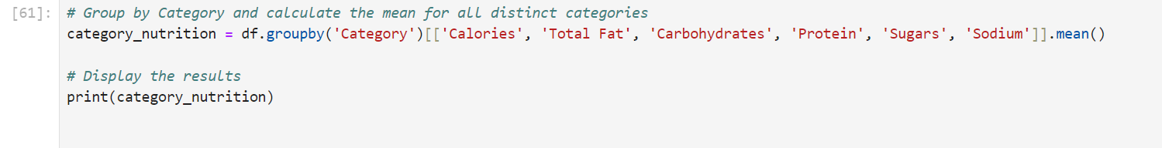

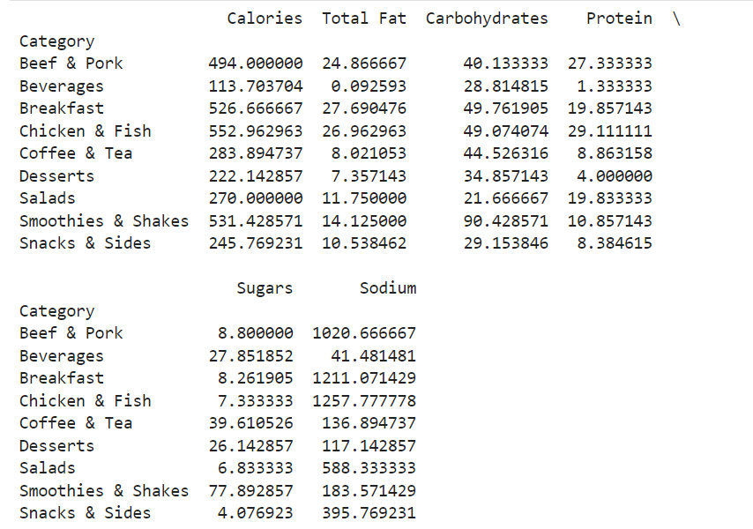

**Recommendations:**

1. **Reduce Sodium in High-Sodium Categories**: McDonald's should consider offering lower-sodium versions of popular breakfast and meat-based items to cater to customers seeking healthier options.
2. **Promote Lower-Sugar Beverages**: Offering low-sugar beverage alternatives or highlighting unsweetened options could appeal to health-conscious customers.
3. **Increase Awareness of Healthier Options**: Promoting **salads** and other balanced meals would help customers make informed choices when seeking lower-calorie, lower-sodium, and lower-sugar options.
4. **Summary of Findings and Insights**

The analysis of McDonald's menu across various food categories provides valuable insights into the nutritional content of popular items, including key nutrients such as calories, fat, protein, carbohydrates, sugars, and sodium. Here’s a summary of the main findings:

A. High-Calorie and High-Sodium Items:

* Chicken McNuggets (40 pieces) and various Big Breakfast options consistently rank among the highest in calorie, fat, and sodium content. These items pose risks for consumers concerned about sodium intake, weight management, or heart health.
* Sodium is particularly concerning in the Beef & Pork, Chicken & Fish, and Breakfast categories, with some items exceeding 1000mg of sodium per serving, which can contribute to hypertension and cardiovascular issues.

B. High-Sugar Items:

* Smoothies & Shakes and Desserts are the main contributors to sugar intake. These items contain excessive amounts of sugar (up to 77.89g per serving), which can negatively impact consumers’ overall health, especially in relation to diabetes and obesity.
* Sugary beverages also contribute little to no protein or healthy fats, making them calorie-dense but nutrient-poor options.

C. Balanced Nutritional Options:

* Salads and Chicken & Fish options provide more balanced nutrition, with relatively lower levels of sodium, sugar, and fat while offering reasonable protein content. These categories are ideal for health-conscious customers seeking high-protein meals without excessive fat or carbohydrates.
* Beverages (when unsweetened) and coffee/tea options are low-calorie and low-sodium, making them good choices for customers looking to minimize their calorie intake.

D. Nutritional Breakdown by Category:

* Beef & Pork: High in protein but also high in fat and sodium.
* Breakfast: High in calories and sodium, driven by processed ingredients such as sausage, eggs, and biscuits.
* Chicken & Fish: Offers a good source of protein but is high in sodium and moderately high in fat.
* Smoothies & Shakes: Extremely high in sugars and carbohydrates, making them a major contributor to excess sugar consumption.
* Desserts: Similar to shakes, desserts are high in sugar with little to no protein or healthy fat.

1. **How the Nutritional Analysis Benefits McDonald’s Customers and the Organization**

A. Benefits to Customers:

1. Informed Dietary Choices:
   * This analysis allows McDonald’s customers to make more informed choices about their diet. By understanding which items are high in calories, fat, sugars, and sodium, customers can tailor their orders to fit their dietary preferences and health goals.
   * Health-conscious customers can opt for salads, grilled chicken, or smaller portion sizes to reduce calorie intake while maintaining protein levels.
2. Portion Control Awareness:
   * The stark differences between portion sizes (e.g., 20-piece vs. 40-piece Chicken McNuggets) highlight how portion control can significantly reduce caloric intake, providing an actionable insight for customers aiming to manage their weight.
3. Healthier Alternatives:
   * The analysis highlights that salads and unsweetened beverages provide a healthier alternative to high-calorie, high-sugar items. Customers seeking to reduce their intake of fat, sodium, and sugars can now easily identify lower-calorie options.

B. Benefits to McDonald’s Organization:

1. Menu Optimization:
   * McDonald's can use these findings to optimize its menu by introducing lower-sodium and lower-sugar options in categories such as Breakfast, Smoothies, and Desserts. Reducing the overall sodium and sugar content can appeal to health-conscious customers while improving the nutritional quality of meals.
   * McDonald’s can also consider smaller portion sizes for high-calorie items (like McNuggets) or promote grilled chicken options to replace fried products in the Chicken & Fish category.
2. Targeted Marketing and Promotions:
   * McDonald’s can leverage this data to market healthier items, such as salads, grilled chicken sandwiches, and low-sugar beverages. This would cater to customers who are increasingly concerned about health and wellness, particularly after the global shift toward healthy eating habits.
   * Nutritional transparency and health-focused marketing can attract new customers and retain those seeking to adopt healthier eating practices.
3. Compliance with Health Regulations:
   * As governments and organizations push for stricter health regulations, such as sodium reductions and calorie transparency, McDonald's can proactively reformulate recipes or create new healthier options to stay ahead of the regulatory curve.
   * By showcasing healthier menu options and offering clear nutritional information, McDonald’s can position itself as a more health-conscious brand.
4. Sustainability and Corporate Responsibility:
   * The focus on healthier options aligns with McDonald’s ongoing commitment to corporate social responsibility (CSR), helping the brand maintain a positive public image. Offering balanced meals and promoting nutrition aligns with CSR goals, enhancing McDonald’s reputation in the market.
5. **Recommendations for Improving McDonald’s Menu:**
6. Reduce Sodium in High-Sodium Items:
   * McDonald’s should work on reducing sodium content in high-sodium items, particularly in breakfast and beef-based meals. This can be achieved by reformulating recipes to use lower-sodium ingredients or offering a healthier version of popular items.
7. Introduce Healthier Beverages:
   * Offering low-sugar or sugar-free beverages, smoothies, and shakes will cater to health-conscious customers looking to reduce their sugar intake. These alternatives can be promoted alongside regular items to provide healthier choices.
8. Portion Control for High-Calorie Items:
   * Items such as 40-piece Chicken McNuggets and large shakes provide excessive calories in a single serving. Offering smaller portions could help customers reduce their caloric intake while still enjoying their favorite items.
9. Promote Grilled and Healthier Options:
   * Promoting grilled chicken sandwiches and salads as healthier alternatives to fried items will attract customers focused on balanced nutrition. These items can be marketed as “better-for-you” options, highlighting their balanced levels of fat, protein, and carbohydrates.
10. Highlight Nutritional Information:
    * Nutritional transparency will help customers make informed choices. McDonald’s can provide detailed nutritional information directly on the menu or app to enable customers to select items based on their dietary preferences (e.g., low-calorie, high-protein).
11. **Conclusion**

This nutritional analysis of McDonald’s menu items provides important insights for both customers and the company. High-calorie and high-sodium items, such as breakfast sandwiches and fried chicken, dominate the menu, while sugar-laden beverages and desserts contribute to excessive sugar intake. However, salads and grilled chicken provide more balanced options for health-conscious individuals.

By using this data, McDonald’s can improve its menu to provide healthier choices while empowering customers to make informed decisions about their food. Furthermore, the insights derived from this analysis can help McDonald’s align its offerings with the growing demand for healthier fast food, ensuring long-term brand growth and customer satisfaction.